**Proposal: Development of a Mobile App for Mental Health Monitoring**

**Introduction**

This proposal outlines a mobile app that helps users monitor mental health metrics, complete guided cognitive behavioral therapy (CBT) exercises, and connect with mental health professionals. The app aims to support individuals seeking consistent mental health management and access to resources.

**Objectives**

1. **Track Mental Health Metrics**: Allow users to log mood, sleep, and stress to observe patterns over time.
2. **Offer CBT-Based Exercises**: Include guided exercises for stress management and cognitive restructuring.
3. **Provide Professional Support**: Connect users to certified therapists for virtual consultations and chat support.
4. **Generate Insights**: Use analytics to provide insights on mental health trends.
5. **Ensure Privacy**: Secure data with industry standards, prioritizing user confidentiality.

**Key Features**

* **Dashboard**: Displays mood, sleep, and stress patterns.
* **Mood & Symptom Tracker**: Logs daily mood and symptoms, integrating with health apps.
* **CBT Exercises**: Offers interactive exercises for managing stress and anxiety.
* **Crisis Support**: Emergency resources and calming techniques for high-stress moments.
* **Professional Access**: In-app chat and video consultations with licensed therapists.
* **Analytics & Goals**: Weekly reports and goals to support mental health progress.

**Target Audience**

Adults (ages 18-50) who want proactive mental health support and resources.

**Technology Stack**

* **Frontend**: Flutter or React Native
* **Backend**: Node.js/Python, Firebase or AWS
* **Security**: AES-256 encryption, OAuth 2.0

**Revenue Model**

* **Freemium**: Basic features are free; premium subscription unlocks advanced analytics and professional support.
* **Subscription Plans**: Monthly and annual options.

**Timeline**

| **Phase** | **Duration** |
| --- | --- |
| Research & Planning | 1 month |
| Design | 1 month |
| Development | 3 months |
| Testing | 1 month |
| Launch | 1 month |

**Budget Estimate**

Total: **$90,000** (Development: $50,000, Design: $15,000, Testing: $10,000, Marketing: $15,000)

**Functional and Non-Functional Requirements**

**Functional Requirements:**

1. **User Management**:
   * Allow users to create accounts and log in securely.
   * Enable profile management with basic details and preferences.
2. **Mental Health Metrics**:
   * Users can log mood, sleep, and stress daily.
   * Display historical data and trends for mood, sleep, and stress.
3. **CBT Exercises**:
   * Provide interactive CBT-based exercises for stress management and cognitive restructuring.
   * Track progress and completion of exercises.
4. **Professional Support**:
   * Enable users to schedule virtual consultations with certified therapists.
   * Facilitate in-app chat for direct communication with professionals.
5. **Analytics and Reports**:
   * Generate weekly reports showing mental health trends.
   * Offer personalized goals based on user data.
6. **Crisis Support**:
   * Provide emergency contact resources and calming exercises for immediate relief.
7. **Integration**:
   * Support integration with health apps for automatic data input (e.g., sleep tracking).

**Non-Functional Requirements:**

1. **Performance**:
   * Ensure the app performs smoothly with minimal latency, even under high usage.
2. **Security**:
   * Encrypt all sensitive user data using AES-256 encryption.
   * Implement OAuth 2.0 for secure authentication.
3. **Availability**:
   * Maintain at least 99.9% uptime to ensure reliable access to services.
4. **Scalability**:
   * Support scalability to handle growing user base and increasing data logs.
5. **Usability**:
   * Ensure an intuitive and user-friendly interface for all age groups (18-50).
6. **Privacy Compliance**:
   * Comply with privacy regulations like GDPR and HIPAA to ensure user data confidentiality.
7. **Cross-Platform Support**:
   * Ensure compatibility with both Android and iOS platforms.

**Inception Plan**

**Project Title: Mental Health Monitoring App**

**1. Vision and Purpose**

The Mental Health Monitoring App aims to empower users to proactively manage their mental well-being. By offering daily tracking tools, cognitive behavioral therapy (CBT) exercises, and access to professional support, the app provides an all-in-one solution for users to monitor and improve their mental health. This app will cater to individuals seeking accessible, reliable mental health resources.

**2. Goals**

* **User Engagement**: Provide interactive tools to encourage consistent tracking and mental health improvement.
* **Support**: Enable connections with licensed professionals for those needing additional assistance.
* **Insight and Analytics**: Offer insights based on user data to help users understand their mental health patterns.

**3. Key Features**

* **Mood and Sleep Tracking**: Daily logs for mood and sleep patterns with visual data summaries.
* **CBT-Based Exercises**: Guided exercises that help manage stress and anxiety.
* **Professional Support**: Access to chat or video consultations with licensed mental health providers.
* **Crisis Support**: Quick access to calming exercises and emergency resources.

**4. Initial Project Milestones**

1. **Planning and Research** (1 month): Define core features and finalize user requirements.
2. **Design Phase** (1 month): Develop UI/UX based on user-friendly design principles.
3. **Development** (3 months): Code core features like tracking, exercises, and professional support.
4. **Testing and Launch** (1 month): Conduct testing, resolve bugs, and launch on app stores.

**5. Risks and Mitigations**

* **Data Privacy**: Implement encryption and secure storage to ensure data privacy.
* **User Retention**: Provide engaging content and gamified rewards to encourage regular use.

**6. Success Metrics**

* **User Retention**: Track daily active users and session lengths.
* **User Satisfaction**: Gather feedback and ratings on app stores.
* **Health Improvement**: Encourage users to track improvement in mental health scores over time.

**Use Case Diagram:**

Here’s a list of actors and use cases for the diagram:

**Actors:**

1. User
2. Therapist

**Use Cases:**

1. Create Account/Login
2. Log Mental Health Metrics
3. View Dashboard
4. Access CBT Exercises
5. Chat with Therapist
6. Schedule a Consultation
7. View Reports and Insights
8. Access Crisis Support
9. Receive notifications
10. AI-Based Insights & Recommendations
11. Gamification & Engagement
12. Offline Mode
13. Integration with Health Apps
14. Multilingual Support
15. **Use Case Table**

| **Use Case ID** | **Use Case Name** | **Actors** | **Description** | **Preconditions** | **Postconditions** | **Relationships** |
| --- | --- | --- | --- | --- | --- | --- |
| **UC-01** | Create Account/Login | User | Allows users to register or log in securely. | User is on the login page. | User is logged in or registered. | **Includes**: Profile Management (UC-02) |
| **UC-02** | Profile Management | User | Enables users to manage personal information, preferences, and settings. | User is logged in. | Profile is updated successfully. | **Included in**: Create Account/Login (UC-01) |
| **UC-03** | Log Mental Health Metrics | User | Users log mood, sleep, and stress daily. | User is logged in. | Data is successfully logged. | **Extends**: View Dashboard (UC-04) |
| **UC-04** | View Dashboard | User | Displays mental health trends visually. | User has logged data. | User sees reports and patterns. | **Includes**: View Reports and Insights (UC-07) |
| **UC-05** | Access CBT Exercises | User | Interactive exercises for stress and anxiety. | User is logged in. | User completes exercises. | **Extends**: AI-Based Insights (UC-10) |
| **UC-06** | Chat with Therapist | User, Therapist | Enables in-app chat with a therapist. | User has an active account. | User receives responses from a therapist. |  |
| **UC-07** | View Reports and Insights | User | Weekly reports on mental health trends. | User has logged data. | Reports are generated. | **Included in**: View Dashboard (UC-04) |
| **UC-08** | Access Crisis Support | User | Provides emergency resources and calming techniques. | User is logged in. | Crisis support is displayed. | **Extends**: Chat with Therapist (UC-06) |
| **UC-09** | Receive Notifications | User | Sends reminders for logging mood, appointments, etc. | Notifications are enabled. | User receives timely alerts. |  |
| **UC-10** | AI-Based Insights & Recommendations | User | Uses AI to analyze trends and suggest coping strategies. | User has logged sufficient data. | Personalized insights are displayed. | **Includes**: View Reports and Insights (UC-07) |
| **UC-11** | Gamification & Engagement | User | Rewards users for tracking and completing exercises. | User has logged data. | Rewards or badges are unlocked. | **Extends**: Access CBT Exercises (UC-05) |
| **UC-12** | Offline Mode | User | Allows mood tracking and exercises without the internet. | User is offline. | Data syncs once online. | **Extends**: Access CBT Exercises (UC-05) |
| **UC-13** | Integration with Health Apps | User | Syncs mood and sleep data from health apps. | User has linked a health app. | Data is synced automatically. |  |
| **UC-14** | Multilingual Support | User | Allows users to switch app language. | User is logged in. | App interface updates to the selected language. |  |

**Use Case Diagram:**

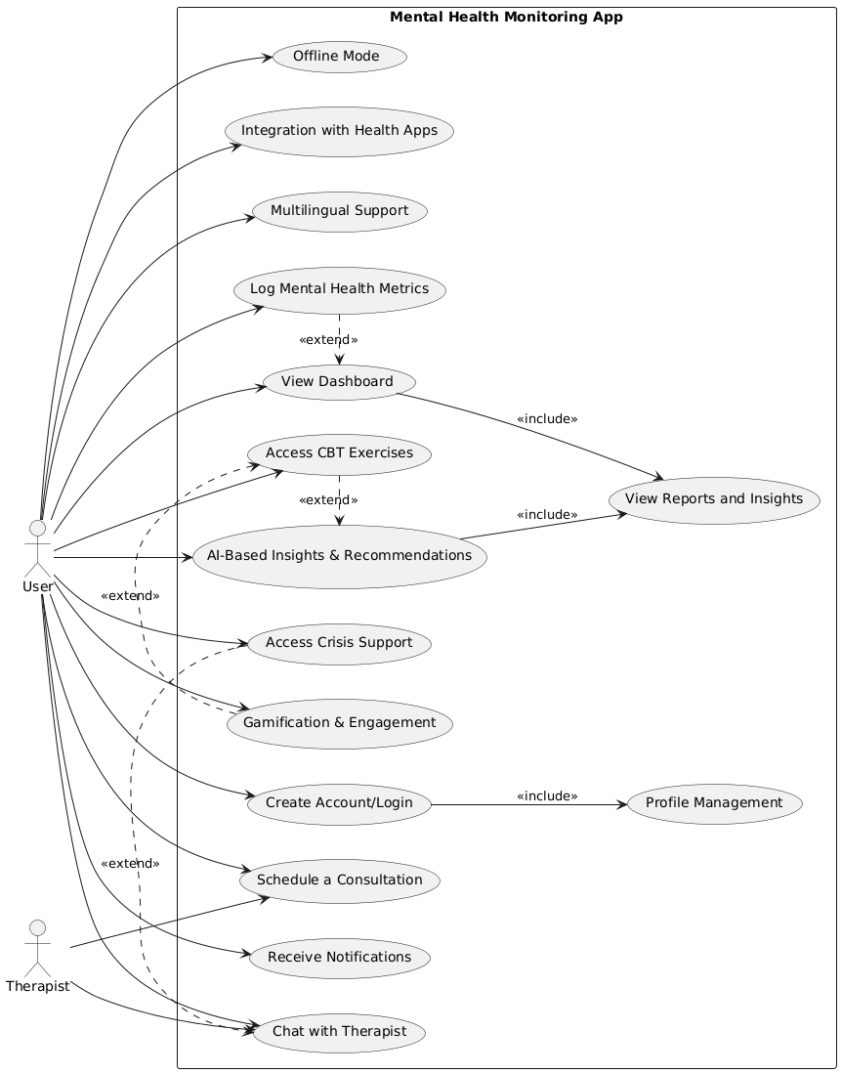

**Test Case Table:**

| **Test Case ID** | **Test Scenario** | **Test Steps** | **Expected Result** | **Pass/Fail Criteria** |
| --- | --- | --- | --- | --- |
| TC-01 | User Login with valid credentials | 1. Open the app  2. Enter valid email & password  3. Tap "Login" button  4. Wait for the dashboard to load | User is successfully logged in and redirected to the dashboard. | User sees the dashboard after logging in. |
| TC-02 | User Login with invalid credentials | 1. Open the app  2. Enter incorrect email/password  3. Tap "Login" button  4. Observe error message | Error message "Invalid credentials" is displayed. | User cannot log in with invalid credentials. |
| TC-03 | Log Mental Health Metrics | 1. Open the app  2. Tap on "Log Mood"  3. Enter mood, stress level, and sleep data  4. Tap "Save" | Data is saved successfully and displayed in the history section. | Data appears in the "Mood Tracker" section. |
| TC-04 | View Dashboard | 1. Open the app  2. Tap "Dashboard" button  3. Observe the graphs displaying mood, sleep, and stress trends. | Trends and insights for mood, sleep, and stress are displayed. | The dashboard accurately displays the user’s mental health data. |
| TC-05 | Access CBT Exercise | 1. Open the app  2. Navigate to "CBT Exercises"  3. Select a CBT exercise  4. Follow the on-screen instructions | Exercise starts and the user can interact with the session. | The exercise is interactive and guides the user through the steps. |
| TC-06 | Chat with Therapist | 1. Open the app  2. Navigate to "Therapist Chat"  3. Send a message to the therapist  4. Wait for a response | Message is delivered successfully and a response is received. | User receives a response from the therapist within the session. |
| TC-07 | Schedule Consultation | 1. Open the app  2. Select therapist  3. Choose an available time slot  4. Confirm the appointment | Appointment is successfully scheduled and confirmation is shown. | User sees the scheduled consultation in their calendar. |
| TC-08 | View Reports & Insights | 1. Open the app  2. Navigate to "Reports"  3. View the weekly mental health insights, trends, and goals | Reports and insights are displayed with trends and recommendations. | Weekly reports are visible with insights into user progress. |
| TC-09 | Access Crisis Support | 1. Open the app  2. Tap on "Crisis Support"  3. View the emergency resources and calming techniques | Crisis resources (contacts, calming exercises) are displayed. | Crisis resources are easily accessible. |
| TC-10 | Receive Notifications | 1. Enable notifications  2. Wait for a mood tracking reminder or upcoming session notification | Notification is displayed according to user settings. | User receives a reminder or notification as per their settings. |
| TC-11 | AI-Based Insights | 1. Open the app  2. View AI-generated insights based on the user's data logs  3. Observe recommendations for improving mental health | Personalized insights and recommendations are provided. | User sees AI-driven insights that are tailored to their needs. |
| TC-12 | Gamification Rewards | 1. Track mood and complete exercises over a week  2. Check for achievement badges or rewards | User unlocks badges or rewards for their progress. | Achievements are unlocked and displayed in the app. |
| TC-13 | Offline Mode | 1. Turn off internet  2. Log mood and complete a CBT exercise  3. Reconnect to the internet  4. Sync data | Data is stored offline and synced once connected. | Data syncs automatically once the app detects an internet connection. |
| TC-14 | Integration with Health Apps | 1. Link a health app (e.g., Apple Health)  2. Log mood or sleep data via the health app  3. Observe if the data syncs with the mental health app | Health data is synced and displayed within the app. | Data from health apps is automatically synced. |
| TC-15 | Multilingual Support | 1. Open the app  2. Navigate to settings  3. Change the app language  4. Observe the app interface switch languages | App interface switches to the selected language. | User sees the app in the selected language. |

**Activity Diagram:**

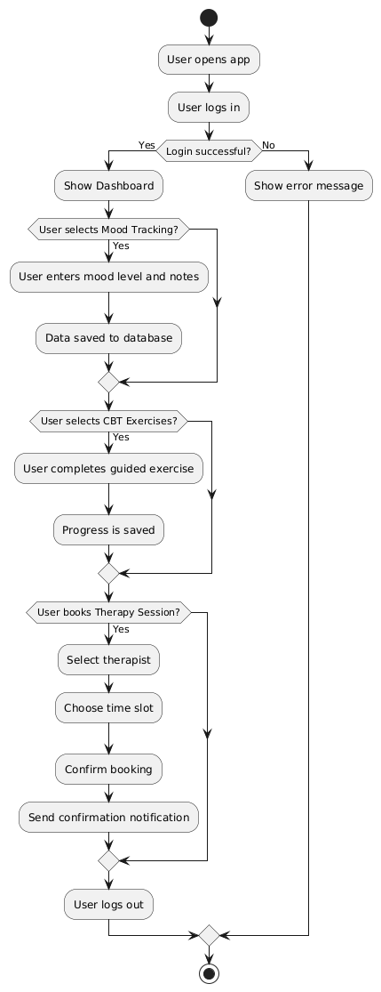

**Class Diagram:**

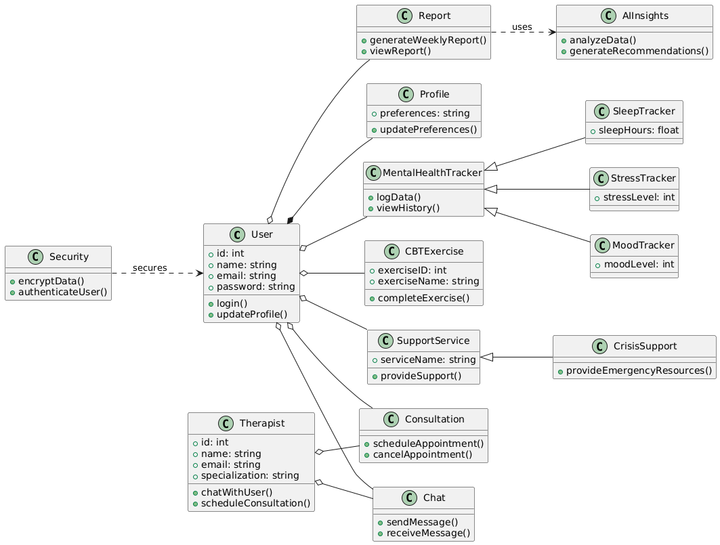

**Sequence Diagram:**

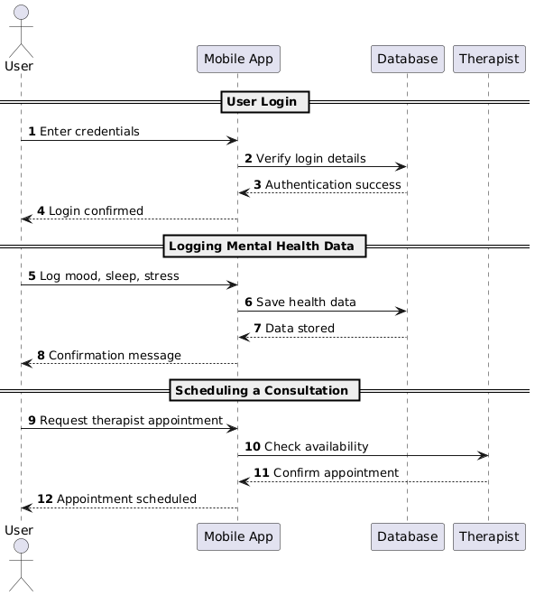

**Architecture Diagram:**

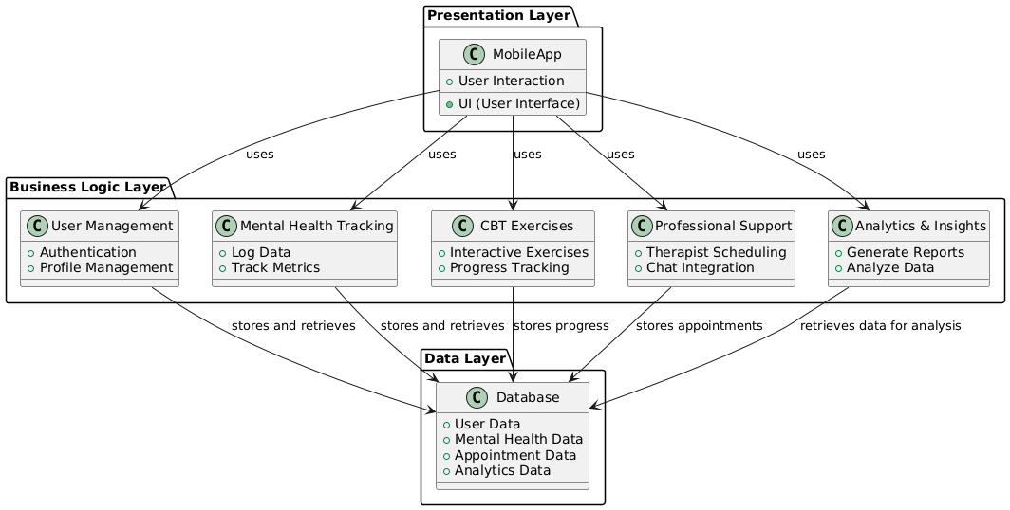

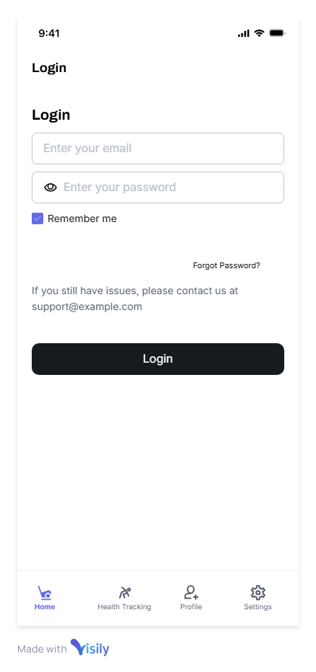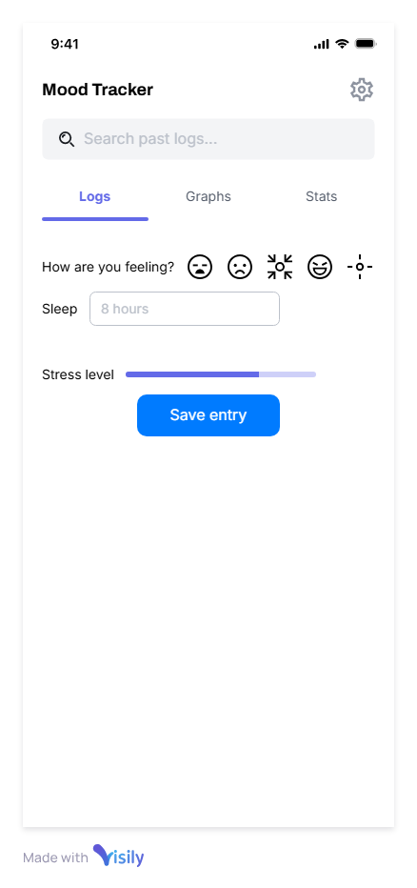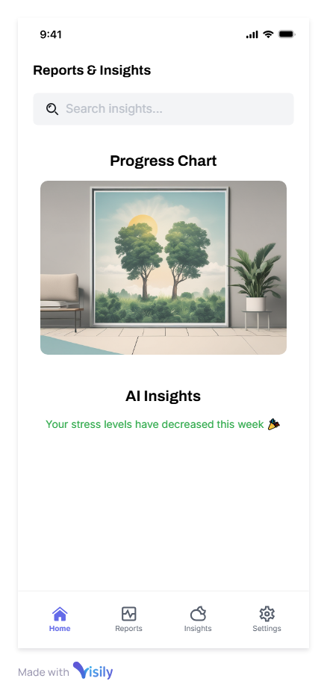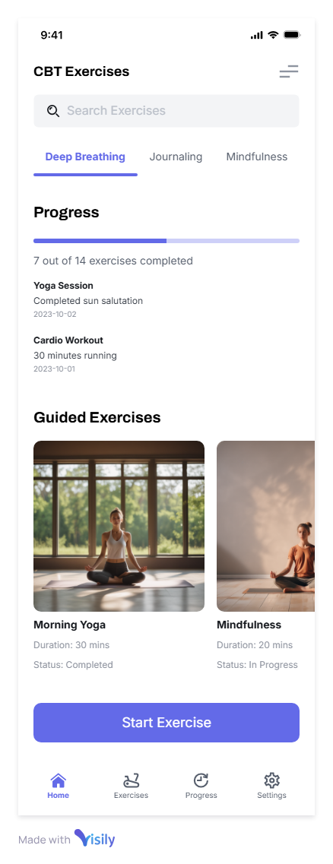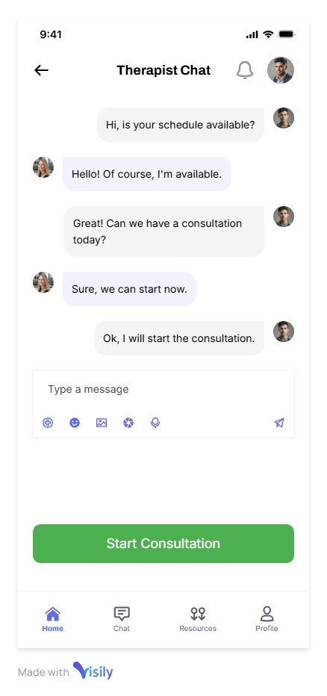

**Conclusion:**

This app aims to make mental health support more accessible by combining self-tracking, CBT exercises, and access to professionals, ultimately empowering users to proactively manage their mental health.